Analysis Report

Data collection zones in the campus.
Open field data : Terrace of Columbus Parking Garage
Building side data : Robinson Quad.
The map is as shown below.

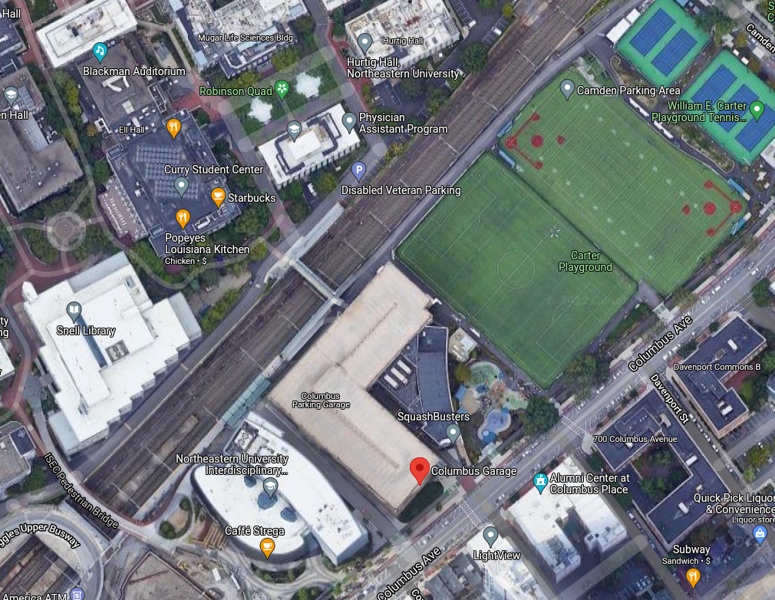
Open field data collection location
Near buildings data collection location
Static open field :

Conditions : Data collected in a open field on the terrace of Columbus garage, Northeastern University
Size : Total size of the data set is 6702 points
Fix quality : 5, which means RTK is in float mode

The red dot in the graph indicates the mean position.
The range of UTM Northing and UTM Easting is 2.5 m.

The rover’s coordinates location started at a far off location at the beginning and when it receives correction from the base, it corrects its location and slowly converge to the mean position. The graph plotted below is for about 6700 data points. Most of the readings are concentrated around the mean and they keep converging towards the mean point. The standard deviation for these points is 1.143 which indicates that the 95% of the data points are in the range of 1.2 m range. This is around 2x times more accurate as compared to the GPS puck that we analyzed in the LAB1.

How standard deviation is calculated?
All the data points are averaged out to find the mean position and the sum of squares of the
differences of all points are calculated which is also known as ‘variance’.
Finally, the square root of the variance is the standard deviation.
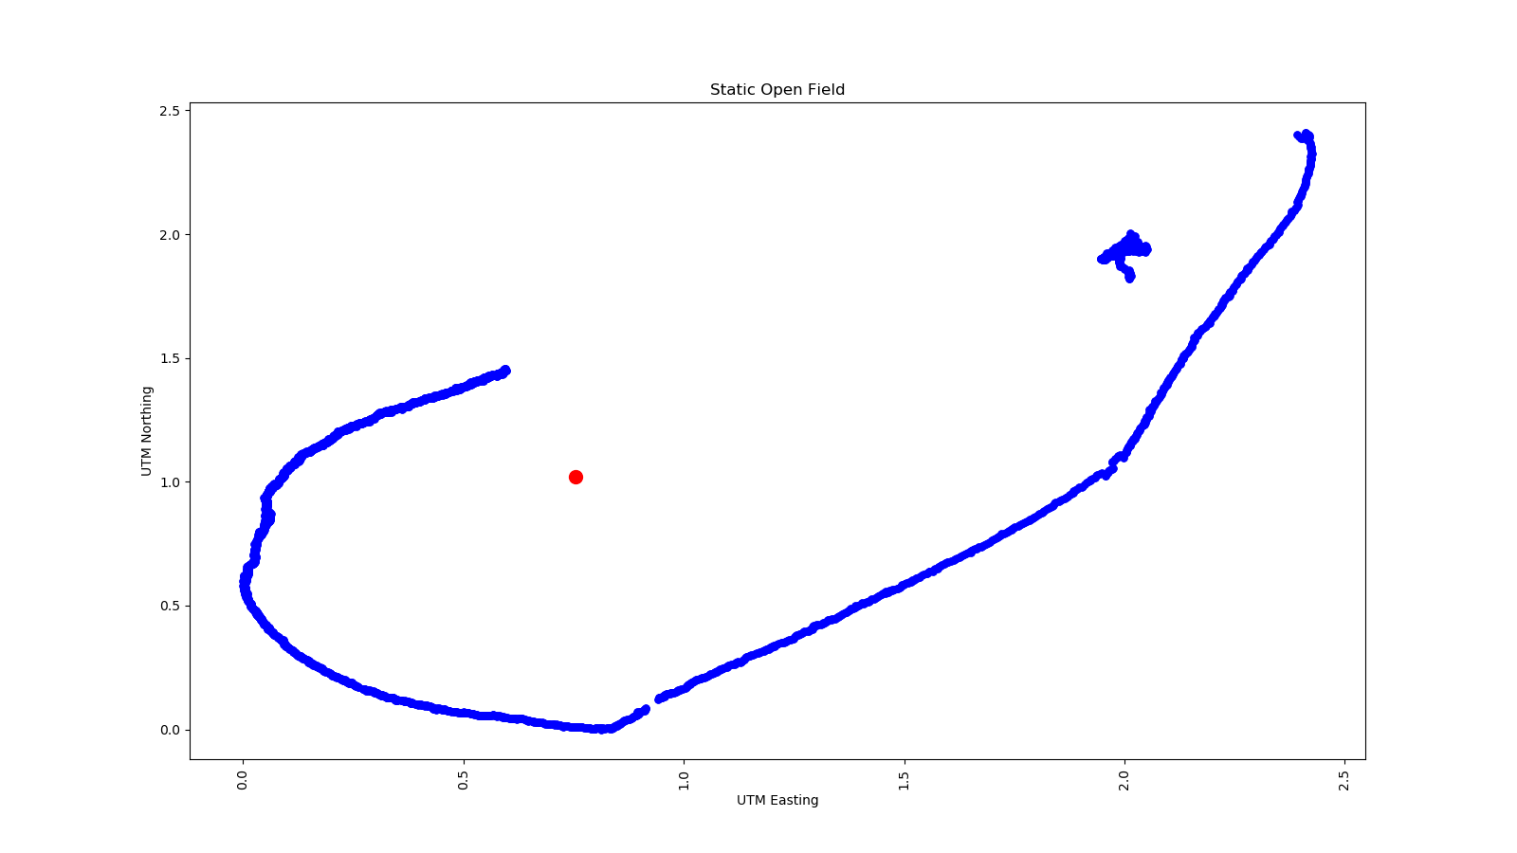

From the histogram we can see that majority of the points lie with in 1 m range and there is a second small peak in the data which could have occurred due to the human obstruction of the gps module. Even the slightest movement obstruction leads to variation in the data.

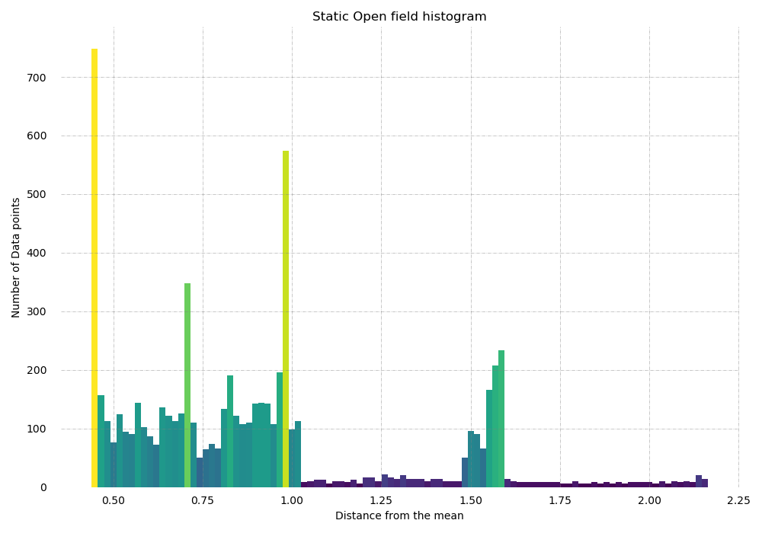

Static Near Buildings:
Conditions : Data collected near buildings around the Robinson quad, Northeastern University
Size : Total size of the data set is 4768 points
Fix quality : 4 & 5, which means RTK is fluctuating between fixed and float mode

The red dot in the graph indicates the mean position.
The range of UTM Northing and UTM Easting is 35 m and 40 m respectively.

Data Pre-processing:
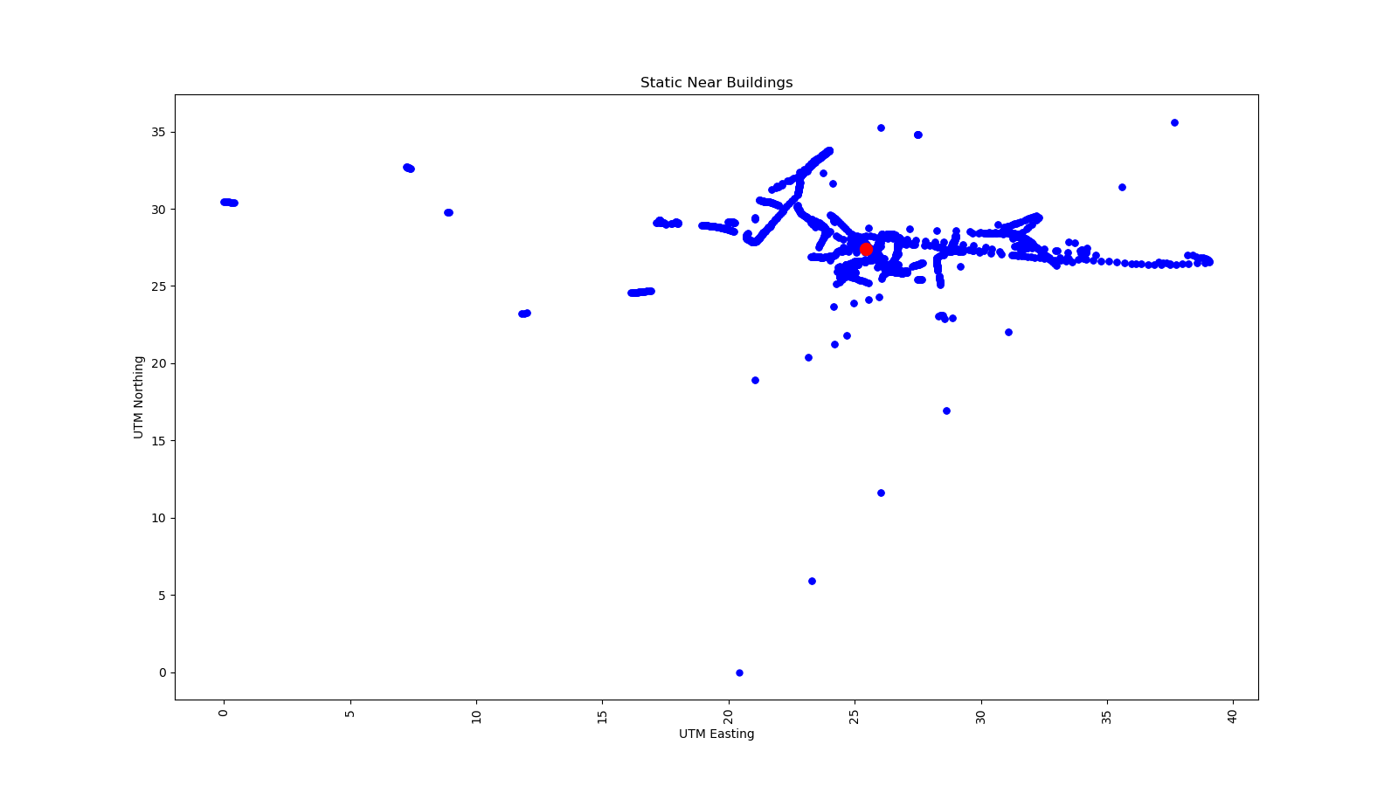
. Most of the times while collecting data, the start and end of the data set are mostly noise and impact the quality of the analysis A few data point were truncated from the collected data to reduce the noise and improve the data quality.

The data quality as opposed to the open field is highly varied and the range of UTM Northing and Easting is also so high. But similar to the open field observation, the location of the rover tends to converge towards the mean however there is a lot of noise in this data. The standard deviation of this plot is 1.763m which is slightly higher than the open field data. We can say that the signal around the buildings is somewhat accurate to up to 1.763m but its it not precise like the open field data.

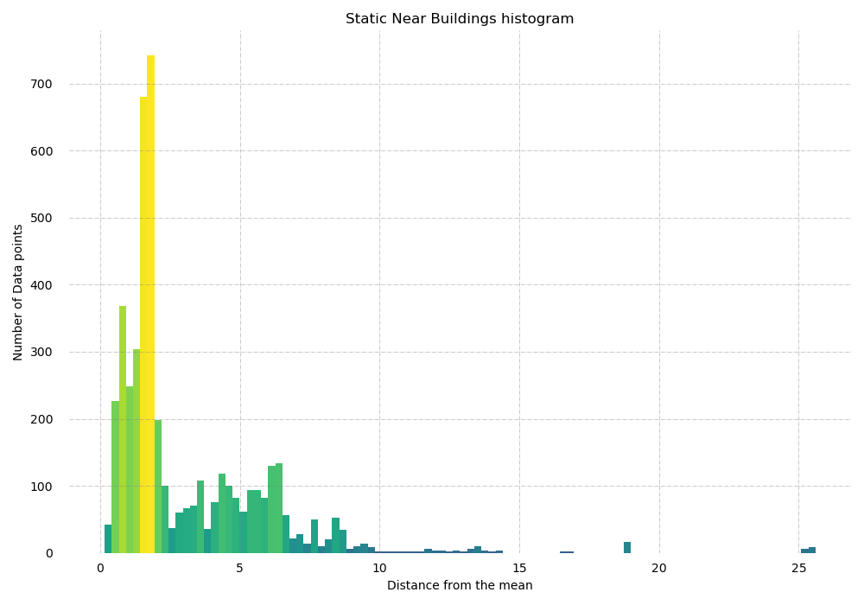

The histogram plot near the buildings is Gaussian distribution with majority of the points lying within 7 m range. However due to noise few points which are beyond 10 m distance from the mean can be ignored as there are very few points and since this is for a stationary data, we can neglect those points. If we do so the range of the UTM Easting and Northing will reduce to a much smaller value than the current range.

Moving Open Field:

Conditions : Data collected in a open field on the terrace of Columbus garage, Northeastern University,
Size : Total size of the data set is 1428 points
Fix quality : 5, which means RTK is in float mode

The data is collected while moving in a rectangular fashion on the top of the Columbus garage. The trajectory is divided in to four different parts as shown in the graph below. Each section is analyzed individually and the standard deviation is calculated based on the regression line for each section.

The standard deviation in this case is calculated by the sum of the squared differences of actual point vs the point on the regression line. Which is then divided by the total number of points in that segment and took the square root of the whole equation to get standard deviation.

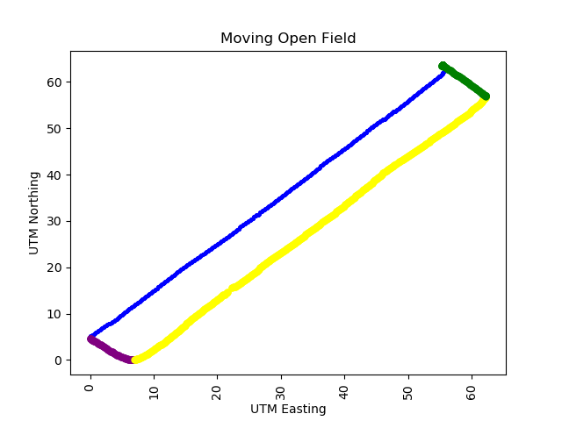

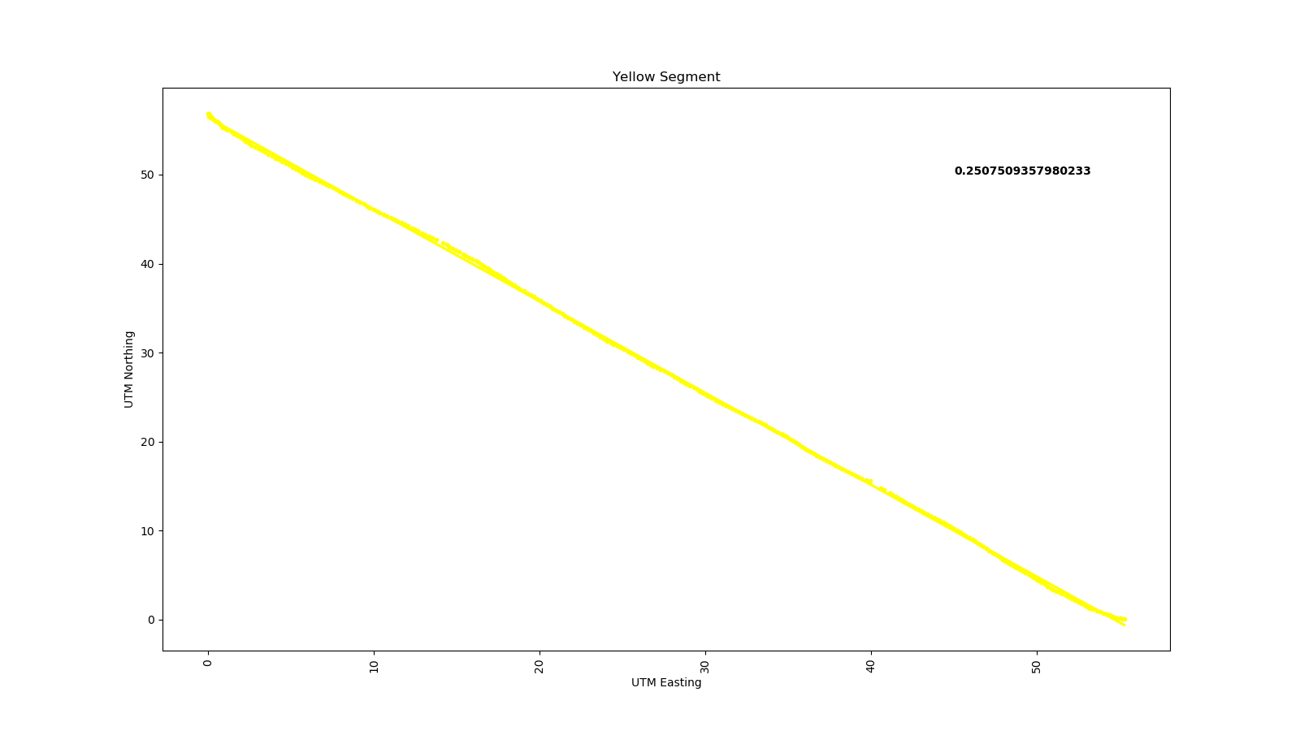
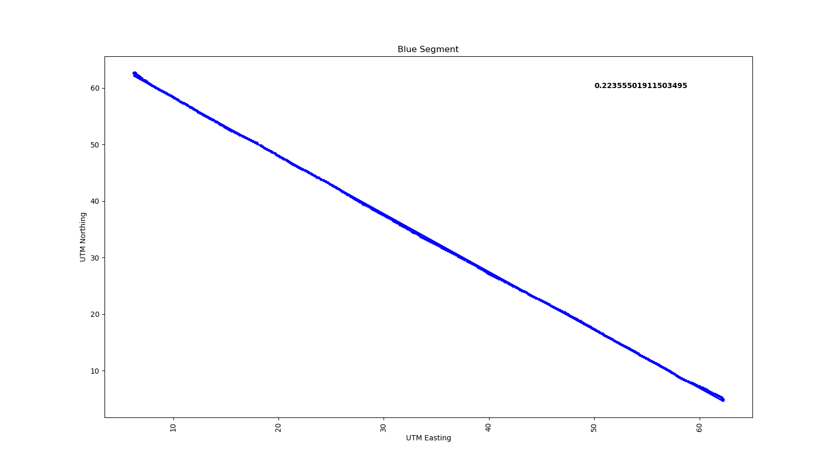
STD Dev:
STD Dev:
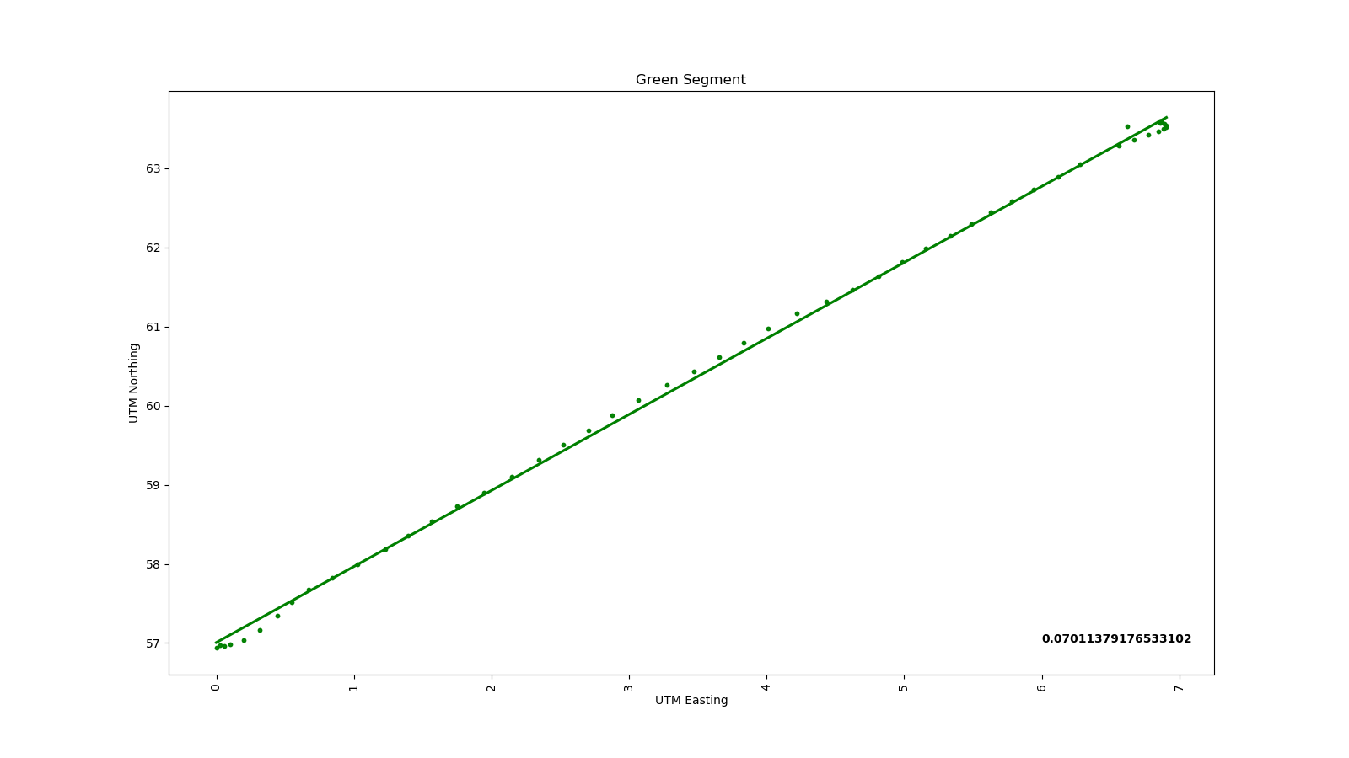
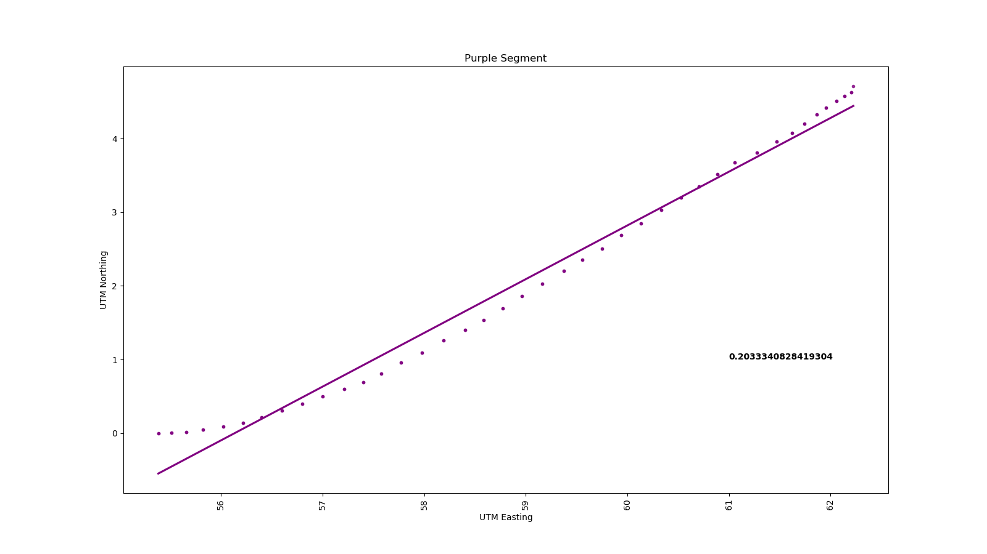
From the individual regression analysis of the above segments, the location of the rover is accurate upto a quarter of a meter which is very high accuracy as compared to the static data. The error in the readings vary from 7 cm to 25 cm. The rover tends to produce accurate data when it is near to the base. As it moves further away, the data points deviate from the best fit line. However the green segment is the most accurate part which might be because of the short distance and more number of data points at one single point as we started from green and moved after a few seconds we started recording the data.

STD Dev:
STD Dev:
Moving Building side:

Conditions : Data collected near buildings around the Robinson quad, Northeastern University
Size : Total size of the data set is 1303 points
Fix quality : 4 & 5, which means RTK is fluctuating between fixed and float mode

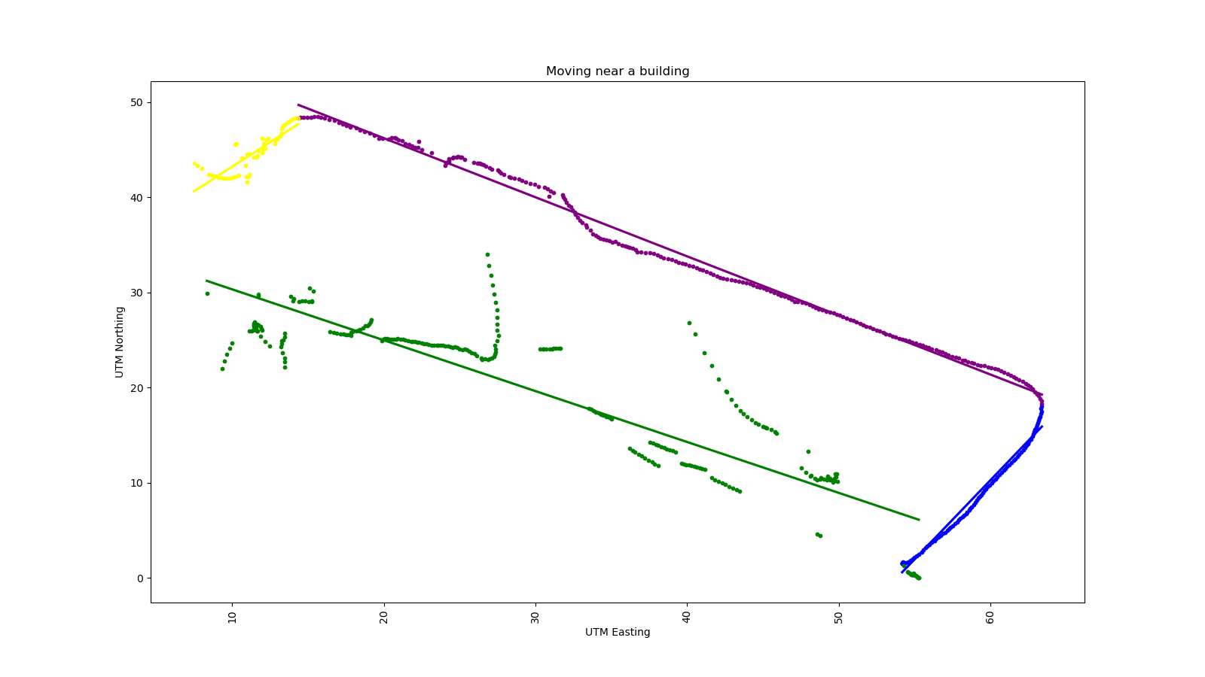
The data is collected while moving in a rectangular fashion around the Robinson quad. The trajectory is divided in to four different parts as shown in the graph below. Each section is analyzed individually by plotting the best fit lines and calculated the standard deviation based on the regression line for each section. The total error is calculated based on the mean of the 4 values.

The standard deviation is calculated similar to the above condition. As you can see the data is uneven and there are a lot of outliers. This is mainly due to the signal obstruction by the buildings surrounding it. Let us now analyze each of the section separately.

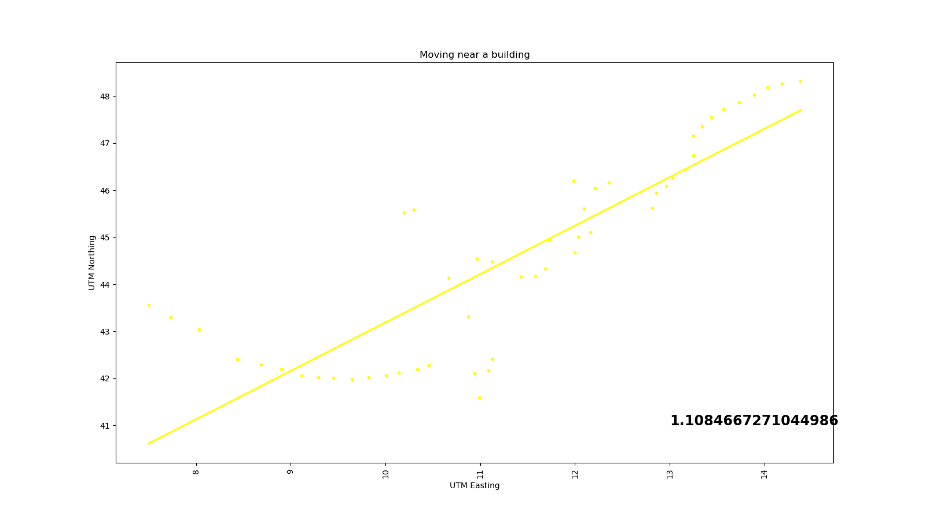
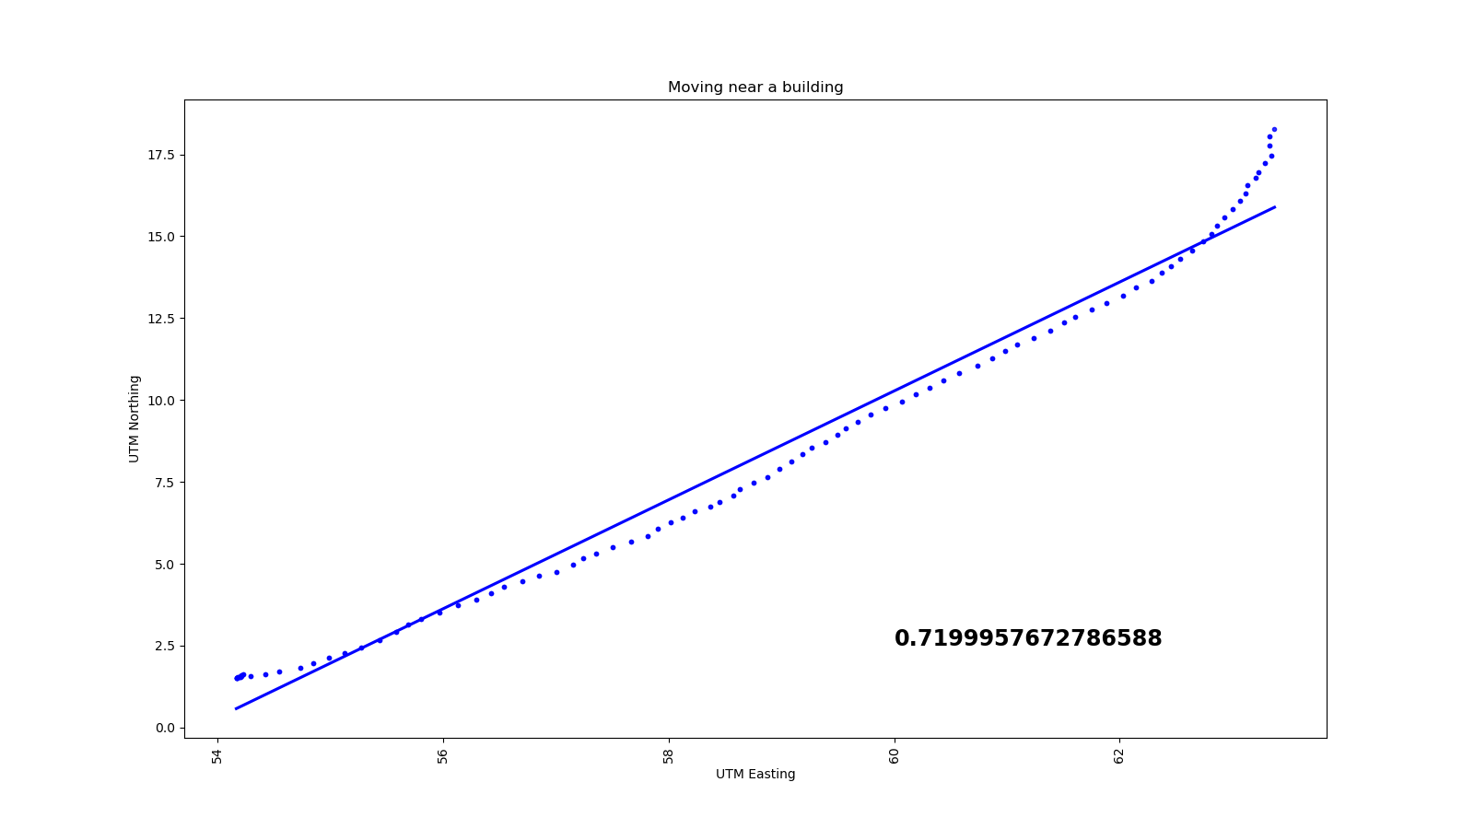

STD Dev:
STD Dev:
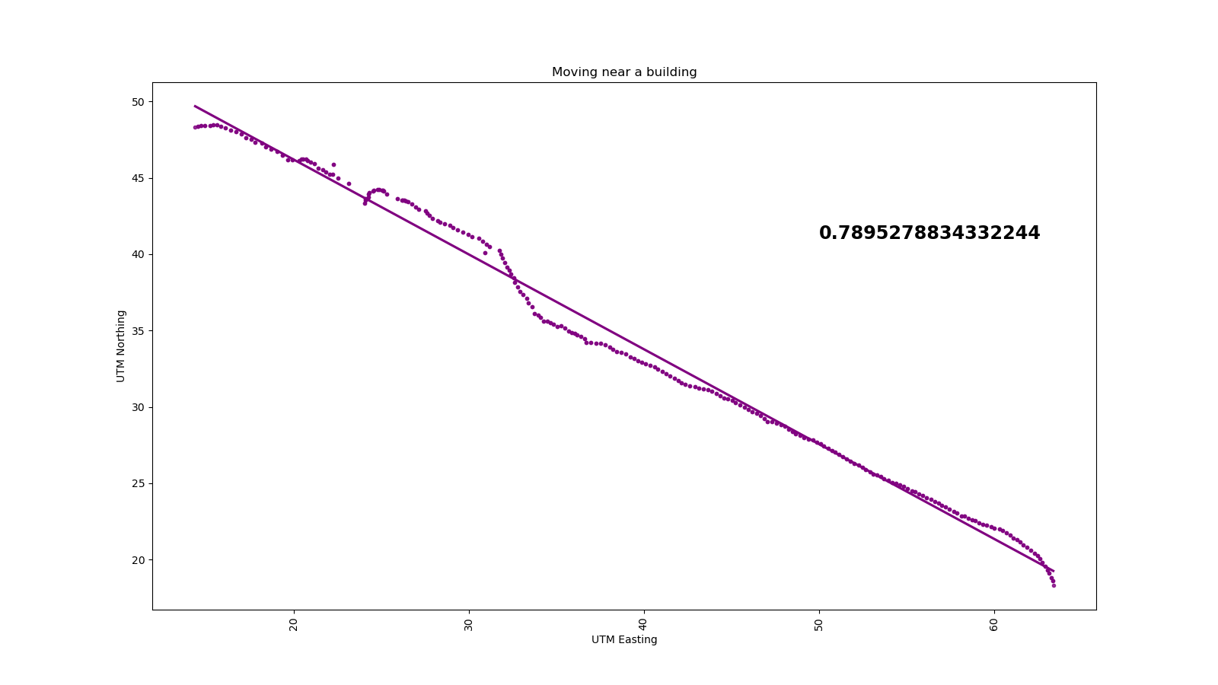
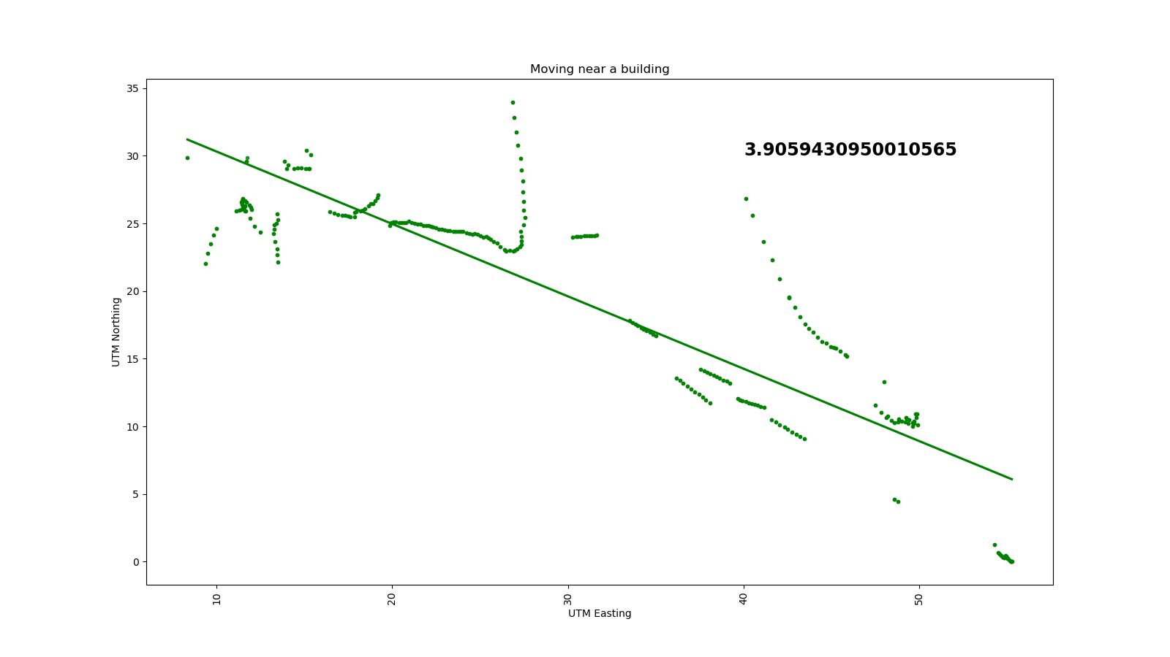
The average error in this data is about 0.7 m to 1m. But in one segment, the data is highly scattered which might be due to walking close to the concrete high raise building the error in this case is about 4 meters which is similar to the normal GPS error that we used in the lab 1. The geographical location of both open field and building side data is not too far apart(~0.2 mile). So we can conclude that the signal is highly sensitive to the environment and relying of GPS or GNSS data is highly not recommended when we want high level accuracy no matter the environment conditions.
STD Dev:
STD Dev:

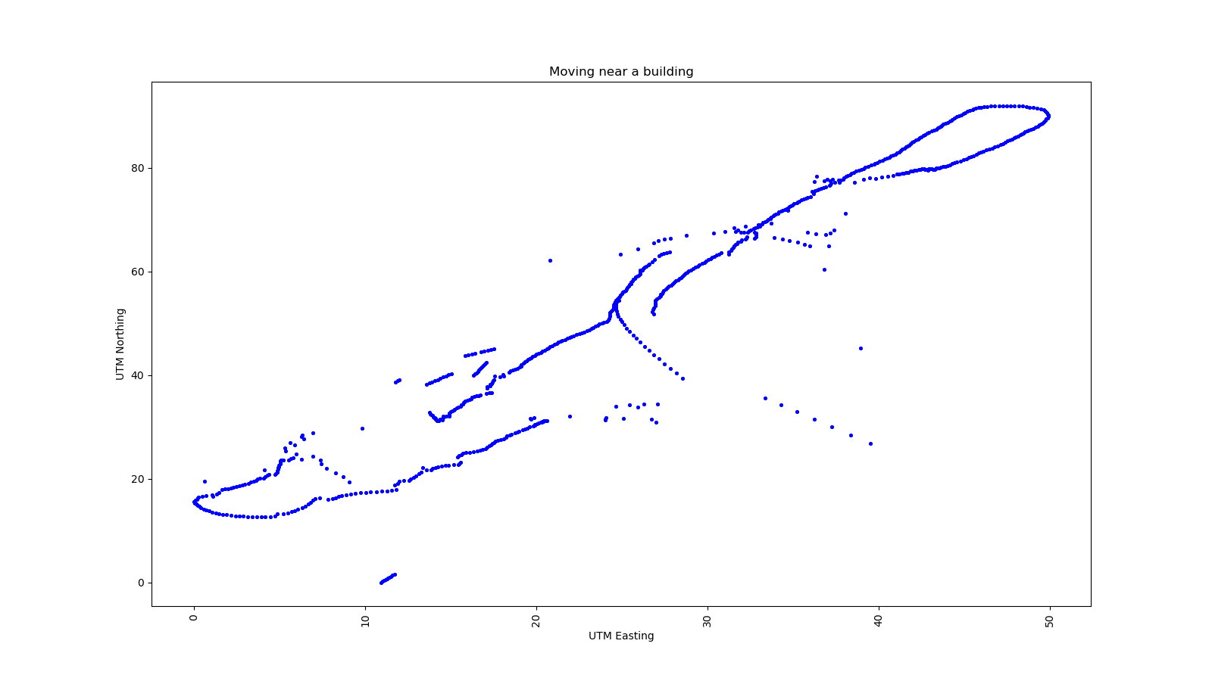
We have collected the data multiple times at a same location and the plots for the same location looks like the ones as shown below.
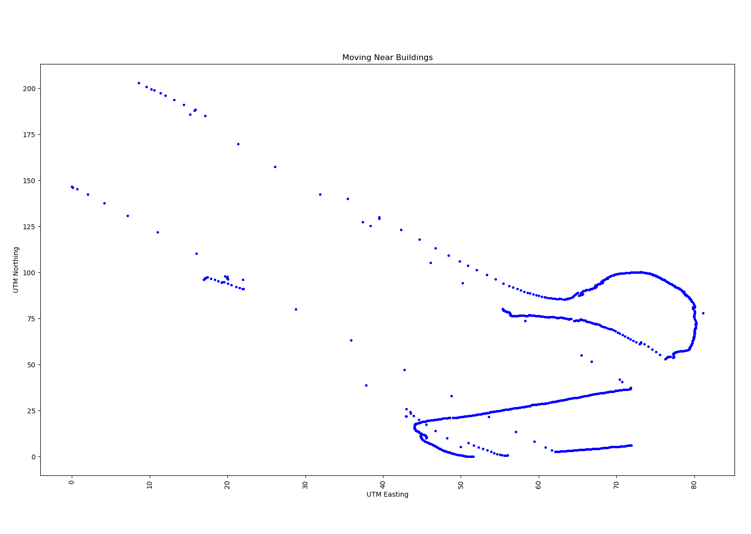

The data is extremely scattered and whole trajectory is not captured. The reason could be due to the bad weather conditions. The other data on which analysis was performed was collected at the same location when the sky was clear.

Conclusion:

 | Static |  | Moving
 | Open | Building | Open | Building
Accuracy  (in m) | 1.14 | 1.78 | 0.19 | 1.62

From the above accuracy table, we can conclude that the RTK module performs best while moving in a open field. This can be used in field surveying areas where there is no obstruction due to trees and buildings. RTK does not work well under these obstructions. Also from the histogram plots, we can say that the precision of the static data in the open field is much better(in the order of 6 times) than the readings around the buildings.

